|  |  |  |  |  |  |  |  |  |  |  |  |
| --- | --- | --- | --- | --- | --- | --- | --- | --- | --- | --- | --- |
| 1 | 2 | 3 | 4 | 5 | 6 | 7 | 8 | 9 | 10 | 11 | 12 |

PADDING XX / XX / XX

TOP / RIGHT-LEFT / BOTTOM

|  |  |  |  |  |
| --- | --- | --- | --- | --- |
| HEADER IMAGEN DE FONDO 84%   |  |  | | --- | --- | | H_TITULO PRINCIPAL 10% / 63% - 4% / 5% | H_MENU  10% / 21% / 5% |  |  |  | | --- | --- | | CAJA DE LISTA DE OPCIONES 5% / 84% / 20%   |  | | --- | | CADA UNA DE LA LISTA T / 84% / T | | |

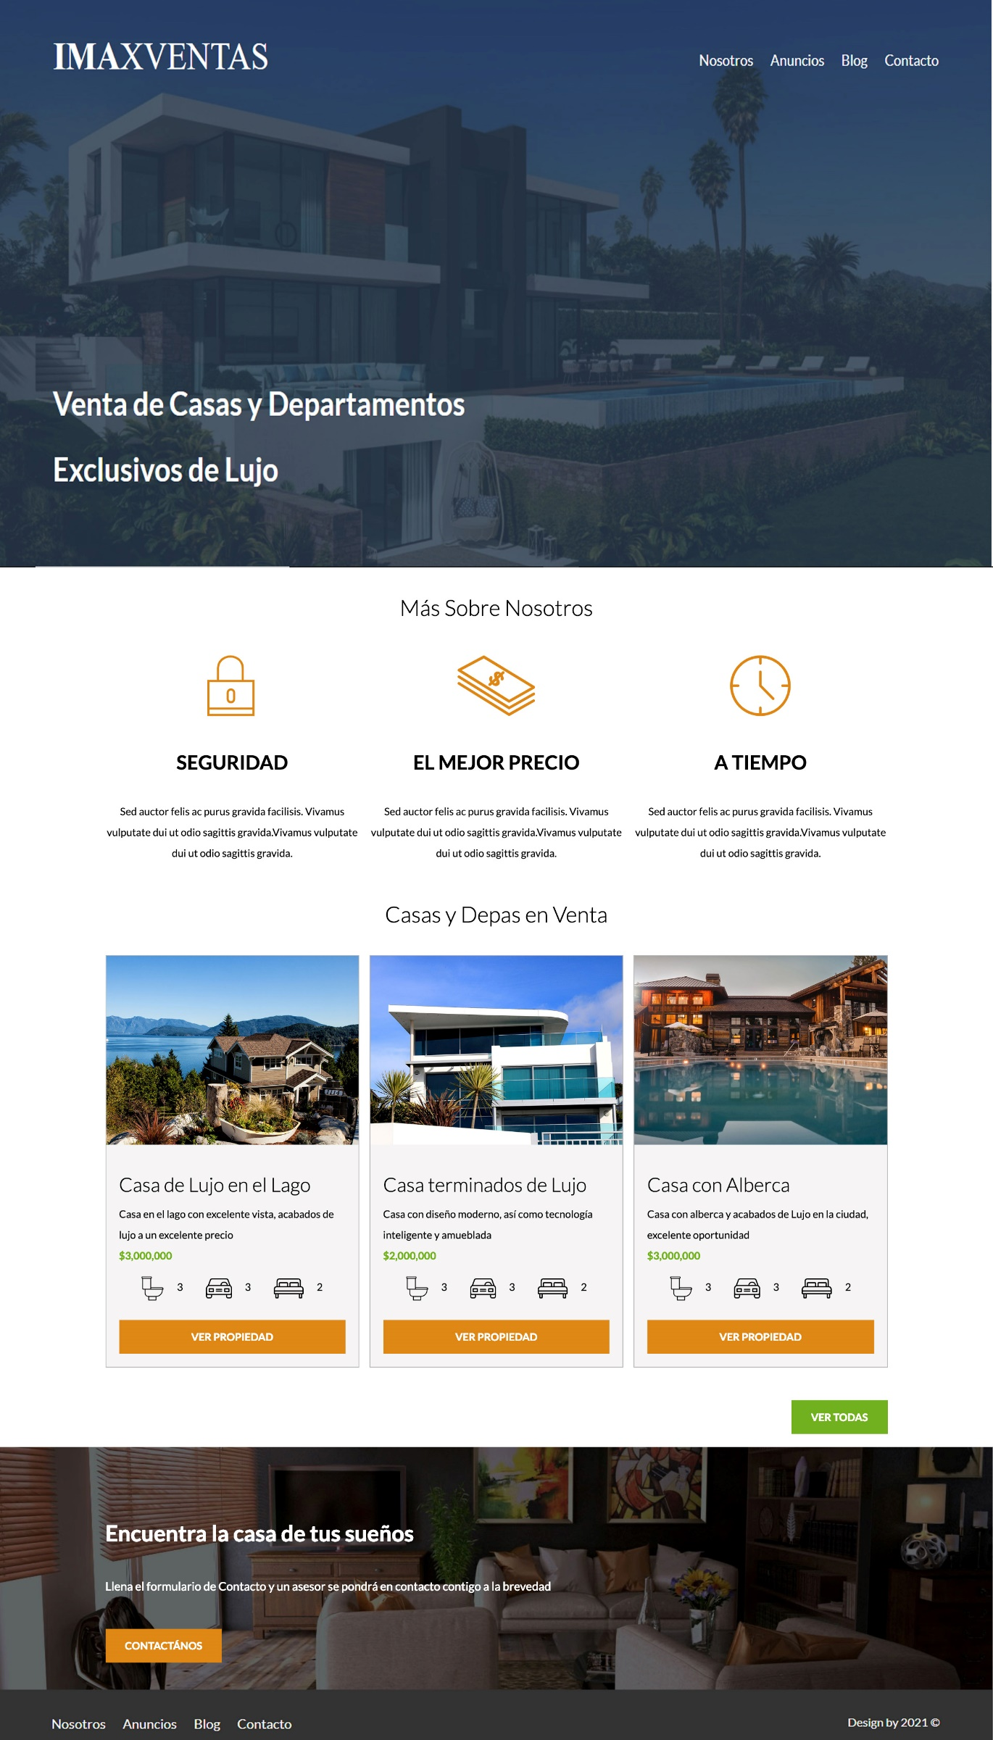

|  |  |  |  |  |  |  |  |  |  |  |  |  |  |  |
| --- | --- | --- | --- | --- | --- | --- | --- | --- | --- | --- | --- | --- | --- | --- |
| FONDO EMPRESA 5% / 84% / 10%   |  | | --- | | TITULO EMPRESA 1% / 84% / 5% | | |  |  |  |  |  |  |  |  |  |  |  |  | | --- | --- | --- | --- | --- | --- | --- | --- | --- | --- | --- | --- | | FORTA1 1% / 28% / 1%   |  | | --- | | F_ICONO 2 / 28% - 2% / 2 | | F_TITULO1 2 / 28% - 2% / 2 | | F_TEXTO1 2 / 28% - 2% / 2 | | FORTA1   |  | | --- | | F_ICONO1 | | F_TITULO1 | | F_TEXTO1 | | FORTA1   |  | | --- | | F_ICONO1 | | F_TITULO1 | | F_TEXTO1 | | | |



|  |  |  |  |  |  |  |  |  |  |  |  |  |  |  |  |  |  |  |  |  |  |  |  |  |  |  |  |  |  |  |  |  |  |  |  |  |  |  |  |  |  |  |  |  |  |  |  |  |  |
| --- | --- | --- | --- | --- | --- | --- | --- | --- | --- | --- | --- | --- | --- | --- | --- | --- | --- | --- | --- | --- | --- | --- | --- | --- | --- | --- | --- | --- | --- | --- | --- | --- | --- | --- | --- | --- | --- | --- | --- | --- | --- | --- | --- | --- | --- | --- | --- | --- | --- |
| FONDO OFERTAS 5% / 84% / 10%   |  | | --- | | OFERTAS TITULO 1% / 84% / 5% |  |  |  |  |  |  |  |  |  |  |  |  |  |  |  |  |  |  |  |  |  |  |  |  |  |  |  |  |  |  |  |  |  |  |  |  |  |  |  |  |  |  |  |  |  |  |  |  |  | | --- | --- | --- | --- | --- | --- | --- | --- | --- | --- | --- | --- | --- | --- | --- | --- | --- | --- | --- | --- | --- | --- | --- | --- | --- | --- | --- | --- | --- | --- | --- | --- | --- | --- | --- | --- | --- | --- | --- | --- | --- | --- | --- | --- | --- | --- | --- | --- | | |  | | --- | | VENTA IMAGEN  50% / 28% - 4% / 10% | | VENTA TITULO | | VENTA DETALLE TEXTO | | VENTA PRECIO | | VENTA ICONOS ITEMS   |  |  |  |  |  |  |  |  |  | | --- | --- | --- | --- | --- | --- | --- | --- | --- | | |  |  | | --- | --- | | A | B | | |  |  | | --- | --- | | A | B | | |  |  | | --- | --- | | A | B | | | | BOTON VENTA | | |  | | --- | | VENTA IMAGEN | | VENTA TITULO | | VENTA DETALLE TEXTO | | VENTA PRECIO | | VENTA ICONOS ITEMS   |  |  |  |  |  |  |  |  |  | | --- | --- | --- | --- | --- | --- | --- | --- | --- | | |  |  | | --- | --- | | A | B | | |  |  | | --- | --- | | A | B | | |  |  | | --- | --- | | A | B | | | | BOTON VENTA | | |  | | --- | | VENTA IMAGEN | | VENTA TITULO | | VENTA DETALLE TEXTO | | VENTA PRECIO | | VENTA ICONOS ITEMS   |  |  |  |  |  |  |  |  |  | | --- | --- | --- | --- | --- | --- | --- | --- | --- | | |  |  | | --- | --- | | A | B | | |  |  | | --- | --- | | A | B | | |  |  | | --- | --- | | A | B | | | | BOTON VENTA | | |



|  |  |  |  |  |  |  |  |
| --- | --- | --- | --- | --- | --- | --- | --- |
| FOOTER   |  |  |  |  | | --- | --- | --- | --- | | IMAGEN FONDO   |  | | --- | | TITULO FOOTER | | DETALLE FT | | BOTON CONTACTO | | | PIE FONDO   |  |  | | --- | --- | | MENU | COPYRIGHT | | |

